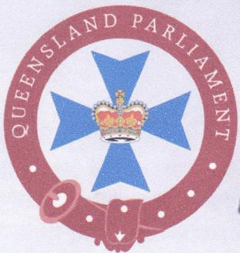
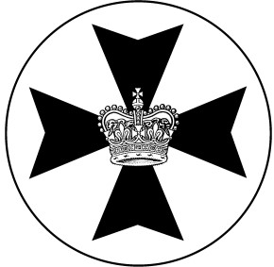
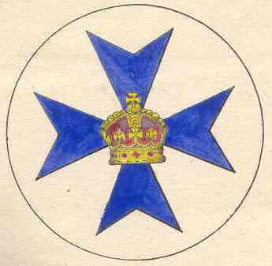
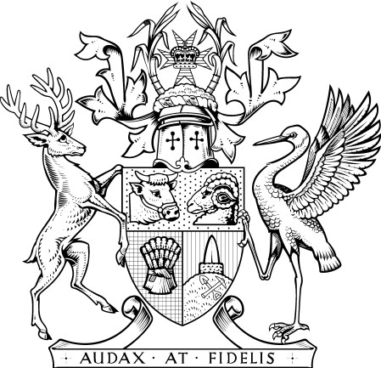
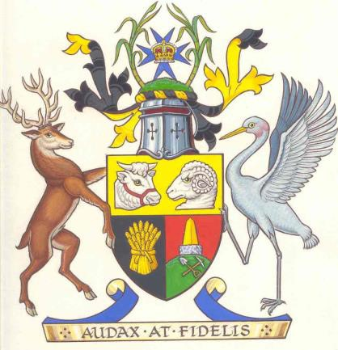
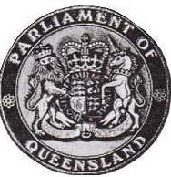
SEALS IN QUEENSLAND

CORPORATE SEALS “CROWN” SEALS

“Queensland Parliament” The Parliament of Queensland
(“Royal Crown” with dipped arches) (Crown of the United Kingdom
with the Lion and the Unicorn)

Badge of (the “State”) Badge of Queensland
th
(“Royal Crown” with dipped arches) (Granted to Queensland 14 July 1876
“Imperial Crown” with raised arches)

“Queensland Government” Government of Queensland
This Seal (with the “Royal Crown”) (Granted under Royal Warrants of
th th
has been used on laws since 1991 and 29 April 1893 and 9 March 1977
th
described in laws from 5 December 1997 “Imperial Crown” with raised arches)
Public Seal of (the “State”) Seal of Queensland
used by corporate “Queensland Government” for use by Government of Queensland
and its corporate “Queensland Parliament”

Refer: Section 41 of Act No. 47 of 1977, Evidence Act 1977 (Qld) and its Reprints after
th
6 June 2002 (commencement date of Constitution of Queensland 2001 Act No. 80).
Statute Law (Miscellaneous Provisions) Act 1997(Qld) Act No. 81 of 1997.

