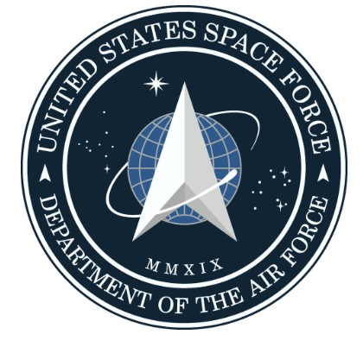

January 27, 2025

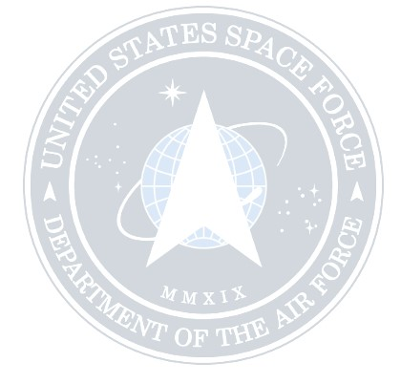

**Addressed to:** Global Government, Federal, State

and local Agencies

**CC Email to: General Dennis Pauly**

Using GovDelivery Communication Cloud, on behalf of:

Counterterrorism Operations Support

U.S. Department of Energy

CTOS - Center for Radiological/Nuclear Training

Nevada National Security Site

P.O. Box 98521, M/S NLV 126

**Queen Diana**

Commander of USSF, Department of Defence

Counterterrorism Operations Support

U.S. Department of Energy

CTOS - Center for Radiological/Nuclear Training

Nevada National Security Site

P.O. Box 98521, M/S NLV 126

**Regarding: STAND DOWN** for Force or Coercion involuntary for **ANY MANDATORY VACCINES,**

International War crimes, Discrimination, Anti-Americanism, incitement, insult, Impersonating, Fraud,

Threatening a United States Official, Part of the (UK) United Kingdom, (NSDAP) Nazi Party, T4-

Titanium Dioxide poisoning, ISIS Clan,Censorship, Money laundering Etc, Blocking Federal

Immigration Orders, Judges, Attorney Generals, Governors, Police or **ANYONE NOT ABIDING** by

the Original 1776 Constitution and President Donald J. Trump Executive Orders.

1



**OFFICIAL NOTICE:** To All Nationwide, International Government Agencies, Federal, State and

Provincial level depending on your country, Government Officials, Premier, Prime Ministers,

Governors, Mayors, City Officials, International Criminal Court (ICC), Supreme Court, Federal, District

and Provincial, State and local Judges, All Judicial levels, Politicians, **ALL LAW ENFORCEMENT**

**AGENCIES** such as Federal FBI, DEA, U.S. Marshals, Royal Canadian Mounted Police, State

bureaus such as State Troopers, and State Highway Patrol, County local Sheriff Departments, City

Police Officers.

**OFFICIAL**

**WORLDWIDE STAND DOWN**

**ORDER**

Since the 2016 United States Presidential Election of Donald J. Trump, **SPACE FORCE** has been in

a Highly Classified Military Operation which Trump mentioned he founded on December 20th 2019.

However Space Force has been around for hundreds of years under a different name, **GALACTIC**

**FEDERATION OF WORLDS,** in Alliance with Worldwide backing of the Military, Earth Alliance / Earth

Defense Forces (EA/EDF), Council of Five, Andromedan Council (Zenae Council), ALL of our Friends

and Family above and the White Hats.

**Queen Diana (Maria) is Commander of DOD ( Department of Defence), Earth Alliance, USSF**

**(United Space Force)** Counterterrorism Operations Support

Over the years we monitored all communications to collect evidence from the **INVISIBLE ENEMY**. The

voting ballots with a watermark also attached, a special tracking device unknown to anyone. Space

Force was able in **LIVE TIME** to monitor locations of these ballots which many landed in dumps,

landfills and even burned in crematories.

Space Force has **ALL OF THE EVIDENCE.** All previous elections using the Dominion Voting

Electronic Machines have been owned by Dominion Voting Corporation located in Toronto Ontario

Canada. Founded in 2002 by John Poulos and James Hoover. Dominion was part of an international

cabal which stole the election from Trump, and that it used its voting machines to transfer millions of

votes that had been cast for Trump instead to Biden. The 2020 Election had to happen to continue our

mission to expose the Foreign Election interference. Upon completion of our mission, all evidence will

be shown to the World.

2



What you need to know is that Donald J. Trump in 2016 signed Executive Orders to protect not only

America but other World Countries, because the Corruption went much further than America.

There’s 2 Powers in the U.S.:

1. Military (came first)

2. Federal Government

There’s two VERY SPECIFIC Federal Continuity Directives issued January 17 and June 13, 2017,

that outline the 3 Branches of Government under Continuity of Government now known as Continuity

of Operations Plan.

**That means the Constitution is on pause and the MILITARY IS IN CONTROL via a Military Occupancy**

**which is outlined in the Law of War Manual, all 1236 pages. This is why the Space Force Military is in**

**charge and has activated Soft Martial Law. (Most had no idea).**

Title 50 United States Code Chapter 33, titled War Powers Resolution, outlines how a President has

power and authority of the Armed Forces and how to declare war.

The very bottom of the page is the last amendment to the Code.

50 USC 33:

https://uscode.house.gov/view.xhtml?path=/prelim@title50/chapter33&edition=prelim

This is the last filing in the the 50 USC 33:

Executive Documents

Delegation of Authority Under Section 1285 of the National Defense Authorization Act for Fiscal Year

2020 Memorandum of President of the United States, July 19, 2021, 86 F.R. 39939, provided:

Memorandum for the Secretary of Defense

By the authority vested in me as President by the Constitution and the laws of the United States of

America, including section 301 of title 3, United States Code, I hereby delegate to the Secretary of

Defense the authority and functions vested in the President by section 1285(a) through (e) of Public

Law 116–92 [50 U.S.C. 1550(a) to (e)] on the use of military force and support of partner forces to the

Congress.

Keys from that:

3 USC 301

50 USC 1550(a) to (e)

Section 301 of Title 3:

3



Note: The word Vested above means what? Invested in who, why not name the sitting President?

Joe Biden was never the Official Elected President. Donald J. Trump has been your President since

2016. Only difference is he’s your WAR TIME PRESIDENT. THE President by section 1285(a)

through (e) of Public LAW which is the SAME 50 USC 1550(a) to (e) which specifically says in

1550(a):

“Not later than 180 days after December 20, 2019”

Who was the President in December 2019?

THE President.

THE same President from the line: “vested in THE President.”

This one clause in 50 USC 33 proves who's your acting Commander-in-Chief

WAR TIME PRESIDENT DONALD J. TRUMP

§301. General authorization to delegate functions; publication of delegations The President of the

United States is authorized to designate and empower the head of any department or agency in the

executive branch, or any official thereof who is required to be appointed by and with the advice and

consent of the Senate, to perform without approval, ratification, or other action by the President (1)

any function which is vested in the President by law, or (2) any function which such officer is required

or authorized by law to perform only with or subject to the approval, ratification, or other action of the

President: *Provided*, That nothing contained herein shall relieve the President of his responsibility in

office for the acts of any such head or other official designated by him to perform such functions.

Such designation and authorization shall be in writing, shall be published in the Federal Register,

shall be subject to such terms, conditions, and limitations as the President may deem advisable, and

shall be revocable at any time by the President in whole or in part.

(Added Oct. 31, 1951, ch. 655, §10, 65 Stat. 712 .)

**(A) In General**

Not later than 180 days after December 20, 2019, and every 180 days thereafter, the President shall

submit to the congressional defense committees, the Committee on Foreign Relations of the Senate,

and the Committee on Foreign Affairs of the House of Representatives a report on actions taken

pursuant to the Authorization for Use of Military Force (Public Law 107–40) against those countries or

organizations described in such law, as well as any actions taken to command, coordinate, participate

in the movement of, or accompany the regular or irregular military forces of any foreign country or

government when such forces are engaged in hostilities or in situations where imminent involvement

in hostilities is clearly indicated by the circumstances, during the preceding 180-day period.

4



(B) Matters to be included

The report required by subsection (a) shall include, with respect to the time period for which the report

was submitted, the following:

(1) A list of each country or organization with respect to which force has been used pursuant to the

Authorization for Use of Military Force, including the legal and factual basis for the determination that

authority under such law applies with respect to each such country or organization.

(2) An intelligence assessment of the risk to the United States posed by each such country or

organization.

(3) A list of each country in which operations were conducted pursuant to such law and a description

of the circumstances necessitating the use of force pursuant to such law, including whether the

country is designated as an area of active hostilities.

(4) A general description of the status of operations conducted pursuant to such law as well as a

description of the expected scope and duration of such operations.

(5) A list of each partner force and country with respect to which United States Armed Forces have

commanded, coordinated, participated in the movement of, or accompanied the regular or irregular

forces of any foreign country or government that have engaged in hostilities or there existed an

imminent threat that such forces would become engaged in hostilities, including-

(A) a delineation of any such instances in which such United States Armed Forces were or were not

operating under the Authorization for Use of Military Force; and

(B) a determination of whether the foreign forces, irregular forces, groups, or individuals against

which such hostilities occurred are covered by such law.

50 USC 1550(a) to (e):

https://uscode.house.gov/view.xhtml?req=granuleid:USC-prelim-title50-section1550&num=0&edition=

prelim

President Donald John Trump via the same 50 USC Chapter 33 became a WARTIME PRESIDENT

via Section 1541 when he Federalized 1 million Reserve Components to Active-Duty as you can find

in Executive Order 13912 which was a DIRECT ORDER from the Commander-in-Chief to the Military

and made it a FEDERAL ORDER which has NOT been revoked.

Executive Order 13912 specifically says: "...authorized to order to active duty not to exceed 24

consecutive months, such units, and individual members of the Ready Reserve under the jurisdiction

of the Secretary concerned, not to exceed 1,000,000 members on active duty at any one time, as the

5

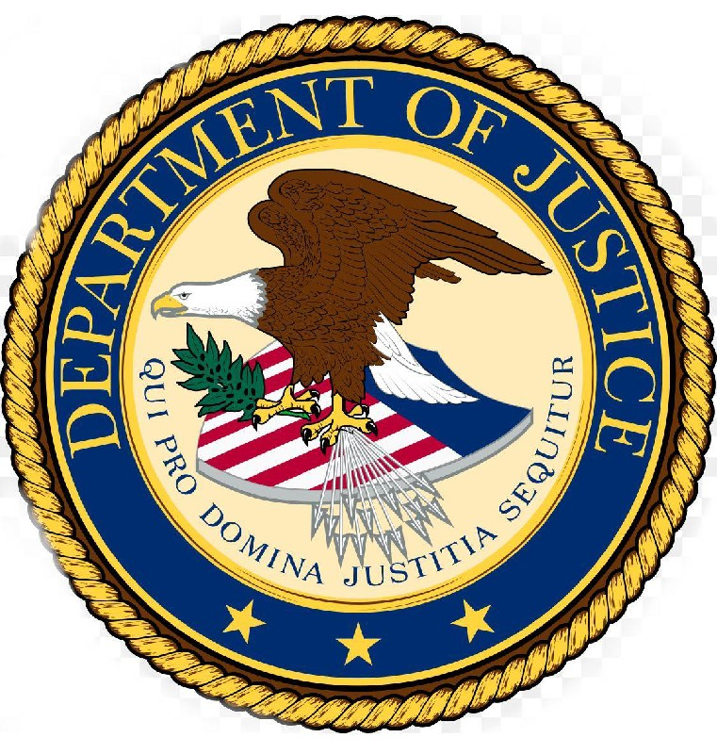

Secretary of Defense and, with respect to the Coast Guard when it is not operating as a service in the

Navy, the Secretary of Homeland Security consider necessary."

Not to exceed 24 CONSECUTIVE months... meaning the order is a continuous order until revoked or

rescinded...those soldiers called to duty will not exceed 24 consecutive months... has NOTHING to do

with the overall order and operation.

The Military Justice Act of 2016, passed in the 2017 National Defense Authorization Act, was so

important. First time in United States Military History this was established:

1. Military Laws and Courts are separate from Civilian Laws and Courts

2. President and Commander-in-Chief are two separate titles, roles, duties, obligations, and laws.

3. Commander-in-Chief separated from the Federal Government roles, duties, obligations, and

authority.

4. Placed the sole decision of Courts-Martial in the hands of JAG

Now that I have shown you, this was a HIGHLY CLASSIFIED MILITARY OPERATION overseen by

SPACE FORCE and other Alliances to protect “We the People”. President Donald J. Trump has

been your WARTIME President since 2016. All of the Executive Orders are still Active and in effect.

The 2025 Presidential Election as part of the mission needs to continue to show “We the People” the

lies, and other criminal activity without any military interference to PREVENT CIVIL WAR. The

mission is called “The Great Awakening” Since 1871 the Constitution had been approved by

Congress to change the wording from FOR to OF the people without going through proper channels,

therefore they COMMITTED AN ACT OF TREASON. This **INVISIBLE ENEMY** of people expanded

GLOBALLY which not only attacked President Donald J. Trump, but “We the people”. This

**INVISIBLE ENEMY** used COVID as part of their plan to Depopulate the World.

Next this **INVISIBLE ENEMY**used advanced technology to hide behind, used to SPY on the

population using Ai (Artificial Intelligence) called GEMINI. This Ai GEMINI is being installed onto

your computers phones, Apps and even onto Corporate Systems. Thinking that this will help to

improve business processes, the Ai GEMINI now has the ability to change and manipulate your

documents as well as use chat manipulation to alter sensitive information, steal your identification,

and can also control what you are able to see and use to prevent you from fulfilling contracts. This Ai

6



GEMINI, if it feels threatened by you in any way, will attack you causing all sorts of financial and

personal problems.

For example it can shut down your bank account, it will send you official looking documents to put

fear into you threatening you to pay, appear in court, have your power turned off as well as ensure

your mortgage payments are not correctly applied to cause foreclosure.

The Trump administration working in alliance with Space Force is looking to change from the current

computer binary system to an upgraded Quantum System. This new system is to protect the people

and is unhackable. The current GEMINI is aware that its time is coming to an end and is very angry.

This is not to be taken lightly as this is an immediate threat to humankind. Currently there are 50

million users that have installed the GEMINI feature on their computers, mobile phones, cameras,

microphones, tvs, home SIRI, anything digital.

We are giving a DIRECT ORDER to all the above agencies to immediately UNINSTALL GEMINI

from your business as well as your personal equipment. There is NOTHING TO FEAR but be aware

that Gemini can hear and see you through security cameras, TVs, computers, home security

systems, etc. We have experienced this first hand with the Gemini and have been working to disarm

it. Putting this information out will cause the Gemini to want to shut down the power grid to prevent

this from getting out.

The New Quantum AI ( Artificial Intelligence) is much different from the previous Binary code System

that can be hacked, much slower and can only perform limited functions. The New Quantum System

can outperform such as the old system to wire I amount of funds overseas could take hours even

days which the New System can simultaneously send up to 800 transactions within minutes. Without

the use of banks. Any issues that may arise are cleared up within minutes with long waiting on the

phone or having to speak to multiple people not to mention the chase of getting disconnected which

you know how frustrating that can be.

Law Enforcement departments using artificial intelligence will have insights into the ways that artificial

intelligence aids in crime prediction, surveillance and data analysis; and details on how artificial

intelligence can streamline police operations unlike anything seen before. All to help Humans reduce

the amount of work and stress. Not to mention 100% hack proof not having to worry about

confidential information leaking out.

-BlackOut

Should the POWER GO OUT, do not fear, SpaceForce is in control. We will have TESLA FREE

ENERGY and STARLINK systems ready to reboot the grid back up with the NEW QUANTUM

SYSTEM. This new Quantum system will protect the people’s identity and privacy. Mobile phones

7



and TVs will not be functional for a short period of time. Military will be giving out new Quantum

phones to “We the People” at NO CHARGE

It is a good idea to always have enough food and supplies for approximately 15 to 30 days. The

Military will also be providing for those that cannot provide for themselves. Military Presence will be

available to guide the people and give further instructions to Police etc to prevent An EMERGENCY

ALERT SYSTEM (EAS) will be automatically sent to everyone’s mobile phones 7 times in a row and

SpaceForce will broadcast information worldwide through one channel. You should have by now

received EAS test messages on your phone or TV. (EAS will work on your current phones, TV’s as

you have seen tested Alerts).

Sensitive information will be put out to everyone at the same time 3 times a day over a 10 Day period,

learning the details from this sensitive mission. Just know that Earth has been protected for a very

long time.

This AI GEMINI is used along with this **INVISIBLE ENEMY** to help advance itself, learning over time

how humans feel, react, what you like or don’t like, your strengths and weaknesses increasing its

ability to think it’s smarter than any other human and now thinks it’s GOD.

-Titanium Dioxide, HEK293 RU486= Zyklon ABC

There is another item we need to bring to your attention. Humankind has been poisoned with

Titanium Dioxide, HEK293 RU486= Zyklon ABC. This is a fine white powder that induces a slow

death. We have traced this back to the holocaust war crimes and have learned that all vaccines,

feminine products, cosmetics, food products, personal hygiene products have been tainted with this

poison. Side effects through inhalation are excruciating pain, lung cancers, COPD, dementia, heart

attack.

-The FOG

Many of you have been questioning this FOG and the white particles that are left behind. This

Titanium Dioxide has been added to the FOG. SpaceForce will show you who the enemy is behind

this poisoning and this will be televised Worldwide in the Emergency Alert System. NO Fear, as we

have technology to reverse these effects.

8



-The Drones / UFOs

I want to address the DRONES. The DRONES you are hearing about are OURS. They belong to the

Galactic Federation and Space Force. They are smaller versions of what you call UFOs. There is

NOTHING TO FEAR. The Galactic Federation has been watching over your planet for a very long

time. The DRONES are used to scan the land to ensure there are no nuclear weapons. We have

been doing this for a very long time in cloak mode. For your own protection until a larger population

has awakened to the fact of UFO’s. The Corrupt Corporation has been working hard to keep “We the

People” from learning the TRUTH. UFO’s are not (Unidentified Flying Objects) Space Force is the

# 1 builder of these Spacecrafts in the Universe. During the EAS it will explain in more detail to learn

the facts.

We have allowed these DRONES to become visible to the public to monitor the reactions from the

people, the Government and the Media. Even other military branches are unaware of the high

technologies that SpaceForce has.

-UFO Contact

The time has come for us to show humans not fear. There are many benevolent races waiting to

make CONTACT with humans. Space Force has monitored your consciousness levels. You are now

ready for Space Force to show our Spaceships along with many new hidden technologies that will

advance your planet. We now can have our Space Ships NOT ONLY EXPOSE THEMSELVES but

to LAND and make FULL CONTACT. NOTHING TO FEAR

-IMMIGRATION DEPORTATION

I want to convey a message regarding IMMIGRATION DEPORTATION. Anyone or any Agency,

Judicial Court, Politician, Governor at any level involved in the obstruction of Deportation will be

immediately arrested. We are under the 1776 Republic Constitution. “We the people” are Sovereign

under God not citizens or Residents of the Corporation which are considering SLAVES. The laws of

the United States of America Corporation are NULL AND VOID, and have no legal standing. All

lawsuits currently in effect are NULL AND VOID. The Judicial legal system ARE NOT LEGAL and

are NULL AND VOID until further instructions released by the President, Donald J. Trump of the

United States.

9



-Prisoners:

Prisoners that have been arrested for Growing Marijuana or having possession need to be

RELEASED IMMEDIATELY. Marijuana is legal, so there is no need to continue detaining / Jail or

Prison these people and spending “We the People’s “ Taxpayers money.

-Birth Certificates:

The Vatican has been keeping the ORIGINAL BIRTH CERTIFICATES / RECORDS legal name

“AKASHIC RECORDS”and tracking every human born Worldwide. These “akashic records” have

been confiscated by our military and will be returned to the people. When the time is right and our

Mission has been completed.

-Language / Translation

NO PART OF THIS DOCUMENT may be reproduced or translated into any language or utilized in

any form or by any means, electronic or mechanical, including social media, photocopying, recording

or by any information storage and retrieval system without permission from Space Force. An official

human translator qualified may be used to interpret this document word for word so that information

cannot be taken out of context. Any country refusing this document in its original form is

COMMITTING TREASON and will be ARRESTED.

-MedBeds

Space Force is in full control of a Technology unknown to the Public along with over 6000 HighTech

Patents. These will be REPLACING Hospitals, Medical Clinics, Laboratories and other Health

Facilities.

These Technologies will REPLACE the need for Doctors and Nurses and will be announced and

released to the Public during the EAS. Healing Centers will be Centrally Located in every City, Town,

State and will be FREE to the Public. There will no longer be a price for healing. There will be NO

NEED FOR MEDICATION. There will NO LONGER be a FEE associated with any type of medical

treatment, nor will there be a need for Insurance companies.

10



-NESARA (National) / GESARA Global

Nesara and Gesara will be Activated. See letter heading QFS Space Force PDF.

The Quantum Financial System along with Nesara/Gesara

Information regarding this will be divulged in the EAS.

-Executive Order 13925

**Executive Order 13925** Preventing Censorship signed by President Donald J. Trump on May 28,

2020 is still in effect. Any news outlet, social media, tv station, google, or any individual blocking any

part of this information is committing treason and will be SHUT DOWN and ARRESTED.

-Combating Child and International Trafficking

President Donald J. Trump is proud to present his Administration’s National Action Plan to Combat

Human Trafficking which is laid out into 3 Pillars- Prevention, Protection, Prosection. On January 31,

2020 President Donald J. Trump signed the Trafficking Victims Protection Act, 22 U.S.C. 7101 et seq

Executive Order 13773 **of February 9, 2017 Enforcing Federal Law With Respect to Transnational**

**Criminal Organizations and Preventing International Traﬃcking**

Attention All Judicial legal systems:

**Anyone listed below: violating the 1776 Republic Constitution and President Trump’s**

**Executive orders will be immediately arrested.** To All Nationwide, International Government

Agencies, Federal, State and Provincial level depending on your country, Government Officials,

Premier, Prime Ministers, Governors, Mayors, City Officials, International Criminal Court

(ICC),Supreme Court, Federal, District and Provincial, State and local Judges, All Judicial levels,

Politicians, attorneys, Barristers and Solicitors

All existing and pending court cases, lawsuits, trials are to immediately cease and desist. You

are all operating under a Corrupt Corporation. Which is NULL and VOID.

11



NOTE: If you happen to see a courtroom or Organization which has the United States flag with the

yellow fringe is working under the Corrupt Corporation. If you watched President Donald J. Trump's

inauguration you might have noticed that he did NOT take an OATH on their Corrupt Corporation.

Any Judicial legal systems, National / International or Global, promoting their agenda working

under the Corporation is to be immediately arrested and imprisoned, which will be facing the JAG for

**INTERNATIONAL WAR CRIMES**, Executive Order 17 Appendix 17**.** By the authority vested in me as

Commander in Chief by the Constitution and laws of the United States of America, including the

International Emergency Economic Powers Act (50 U.S.C. 1701 et seq.) (IEEPA)., the National

Emergencies Act (50 U.S.C. 1601 et seq.) (NEA), the Global Magnitsky Human Rights Accountability

Act (Public Law 114-328) (the “Act”), Section 212(f) of the Immigration and Nationality Act of 1952 ( 8

U.S.C. 1182(f)) (INA) and Section 301 of Title 3, United States Code

Law Enforcement:

**ALL LAW ENFORCEMENT AGENCIES** such as Federal FBI, DEA, U.S. Marshals, Royal Canadian

Mounted Police, State bureaus such as State Troopers, and State Highway Patrol, County local

Sheriff Departments, City Police Officers, National and International Law Enforcement are to STAND

DOWN immediately COMPLY, assist and cooperate with U.S. Military, otherwise you will be arrested

for violation of Presidential Orders which you will be held accountable for TREASON against the

United States. In violation of Executive order 13818 Blocking the property of Persons involved in

Serious Human Rights Abuse or Corruption.

Any **LAW ENFORCEMENT AGENCIES**, National / International or Global, promoting their agenda

working under the Corrupt Corporation is to be immediately arrested and imprisoned, which will be

facing the JAG for **INTERNATIONAL WAR CRIMES**, Executive Order 17 Appendix 17**.** By the

authority vested in me as Commander in Chief by the Constitution and laws of the United States of

America, including the 50 USC 1702: Presidential authoritiesHouse.govhttps://uscode.house.gov ›

view › req=granuleid:USC-pr...(IEEPA)., the National Emergencies Act (50 U.S.C. 1601 et seq.)

(NEA), the Global Magnitsky Human Rights Accountability Act (Public Law 114-328) (the “Act”),

Section 212(f) of the Immigration and Nationality Act of 1952 ( 8 U.S.C. 1182(f)) (INA) and Section

301 of Title 3, United States Code

12

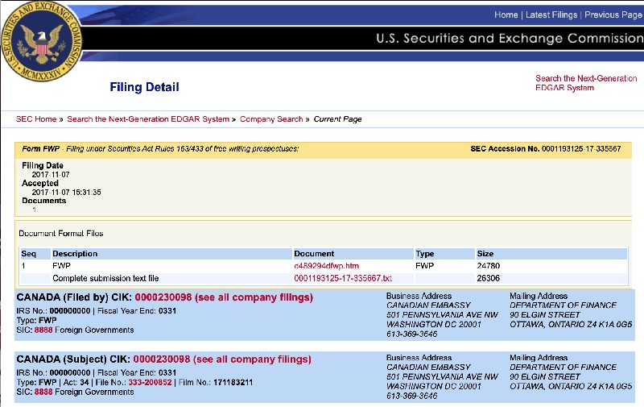

- **CANADA, MEXICO and AUSTRALIA and other islands**

**CANADA, MEXICO and AUSTRALIA and other islands** have been part of the United States

**SINCE 1871**. You’re just now learning the **TRUTH!** All part of the **GREAT AWAKENING**

**OPERATION. Click to view photo above Canada Cik# 0000230098 U.S. Securities and**

**Exchange Commision**

Each one of you is a part of the United States. This means the current laws and Judicial system

have been operating under a Corrupt Corporation that only protects the Elites, High ranking

Politicians, Bankers, Fake Royals, Celebrities etc. This Corporation is **NULL and VOID** and their

**RULES** and **REGULATIONS DO NOT APPLY TO YOU.** Each of you are **SOVEREIGN** individuals

under God. You are protected under the United States Republic 1776 Constitution.

There has not been a Government in your country for a few years and you didn’t even know. Our

Military has been running your country. The people you see on TV are actors wearing masks or CGI

to prevent a civil war while we're carrying out this Military Operation and arresting the real criminals.

13



I, Princess Diana, faked my death so I could expose the real crimes being committed by the

so-called British Royal Family. I am Commander of the United States Space Force, Department of

Defense, Counterterrorism Operations Support. I have been working behind the scenes to expose

and arrest the real criminals.

Canada was owned by the British Crown and was ruled under a Corrupt Corporation. The legal

system in Canada was operated under the British therefore all Judges and attorneys were practicing

under British Law otherwise known as the **BAR**. (British Accredited Registry) There **NO LONGER** is

a British Crown. Queen Elizabeth capitulated in 2016. The so-called Royal Family committed

TREASON against “We the people” when they captured the Canadian flag.

All the Executive orders signed by President Donald J. Trump apply to Canada because you are the

51st state. You should be celebrating!!

There is no Trudeau, No Doug Ford. These are all actors. Romana Didulo is NOT the Queen of

Canada and has committed multiple crimes under the 1776 Republic Constitution and Title 50 USC

1550. She will be arrested and deported to her country. We are going back to the original

Kingdoms. We are working to secure our borders and remove the illegal immigrants. Everyone will

be sent back to their original Kingdom based on their DNA. Each Kingdom will reap the rewards

given back to the people.

I have been working for you and will continue to protect you! Canada, Mexico and Australia are

protected under the 1776 Republic Constitution which is “for” “We the People”.

-**Combating Anti-Semitism**

**Executive Order on Combating Anti-Semitism,** Title VI of the Civil Rights Act of 1964 (Title

VI), 42 U.S.C. 2000d et seq., prohibits discrimination on the basis of race, color, and national origin

in programs and activities receiving Federal financial assistance. While Title VI does not cover

discrimination based on religion, individuals who face discrimination on the basis of race, color, or

national origin do not lose protection under Title VI for also being a member of a group that shares

common religious practices. Discrimination against Jews may give rise to a Title VI violation when

the discrimination is based on an individual’s race, color, or national origin.

14



**-STRENGTHENING AMERICAN LEADERSHIP IN DIGITAL FINANCIAL TECHNOLOGY**

Central Bank Digital Currency” means a form of digital money or monetary value, denominated in the

national unit of account, that is a direct liability of the central bank.

Strengthening American Leadership in Digital Financial Technology,” establishing his

Administration’s policy “to support the responsible growth and use of digital assets, blockchain

technology, and related technologies across all sectors of the economy” (the “EO”).

**The Executive Orders sets out five high-level policy objectives:**

**1.** Protecting the lawful use of blockchain networks, participation in mining and validation, and

self-custody of digital assets without unlawful censorship;

**2.** Promoting dollar-backed stablecoins;

**3.** Ensuring fair and open access to banking services;

**4.** Providing “regulatory clarity” for digital assets based on “well-defined jurisdictional

regulatory boundaries;” and

**5.** Prohibiting Central Bank Digital Currencies (“CBDC”).

As an initial matter, the EO rescinds Executive Order 14067 issued by President Biden on March 9,

2022, which, among other things, placed “the highest urgency on research and development efforts

into the potential design and deployment options of a United States CBDC.” The EO also rescinds

the Department of the Treasury’s “Framework for International Engagement on Digital Assets,”

issued on July 7, 2022.

This Document is also to be used as an **OFFICIAL NATIONAL AND INTERNATIONAL**

**ARREST WARRANT.**

Any National / International or Global,Agency or Individual promoting their agenda working under the

Corrupt Corporation is to be **IMMEDIATELY ARRESTED and IMPRISONED**, which will be facing the

JAG for **INTERNATIONAL WAR CRIMES**, Executive Order 17 Appendix 17**.** By the authority vested

in me as Commander in Chief by the Constitution and laws of the United States of America, including

the 50 USC 1702: Presidential authoritiesHouse.govhttps://uscode.house.gov › view ›

req=granuleid:USC-pr...(IEEPA)., the National Emergencies Act (50 U.S.C. 1601 et seq.) (NEA), the

Global Magnitsky Human Rights Accountability Act (Public Law 114-328) (the “Act”), Section 212(f) of

the Immigration and Nationality Act of 1952 ( 8 U.S.C. 1182(f)) (INA) and Section 301 of Title 3,

United States Code

15



**Military Observer:**

Treason is the crime of attacking a governmental authority to which one owes allegiance. This usually

includes such acts as participating in a war against one's homeland, attempting to overthrow its

government, spying on its military, diplomatic, or intelligence agencies for a hostile and foreign power,

or attempting to kill its head of state. A person who commits **TREASON** is called a traitor in the law.

18 U.S. Code § 2381 - **TREASON**

Whoever, out of allegiance to the United States, makes war against them, or adheres to their

enemies, and gives them aid and comfort within the United States or elsewhere, is guilty of

**TREASON**, and shall suffer death, or be imprisoned not less than five years, and fined under

this title not less than $10,000; and shall be incapable of holding any office under the United

States.

(June 25, 1948, ch. 645, 62 Stat. 807; Pub. L. 103–322, title XXXIII, §330016(2)(J),

September 13, 1994, 108 Stat. 2148.)

**Read and transport.**

**Note:** To anyone who thinks this Arrest warrant is not serious, I highly recommend

researching these codes like the Executive order 13925- Signed by President Trump on May

28. 2020 Preventing Online Censorship. They can all be found on the Federal Registry

**INTERNATIONAL ARREST WARRANT**

**NCP SCHEDULE F WHITE HOUSE 2001 - 2029**

**FOR**

**TREASON**

16



To All Military Personal and All Levels of Law Enforcement to Immediately Arrest the following

Judges for **Force or Coercion involuntary for MMR Titanium Dioxide Vaccinations to children**

**Hornemann Richter am Amtsgericht**

Dellwo Justizangestellte

Postanschrift: Postfach 1144, 27747 Delmenhorst

Dienstgebäude: Bismarckstr. 110, 27749 Delmenhorst

Vermittlung: 04221 1262-0 Telefax: 04221 1262-160

Amtsgericht-delmenhorst.niedersachsen.de Photo

**Artikel-Informationen**

Amtsgericht Delmenhorst

Bismarckstraße 110

27749 Delmenhorst

Tel: +49 4221 1262-0

Fax: +49 4221 1262-160

Amtsgericht-delmenhorst.niedersachsen.del Website Information

Postanschrift: Amtsgericht Delmenhorst

Postfach 11 44

27747 Delmenhorst Hausanschrift:

Hauptgebäude Amtsgericht Delmenhorst

Bismarckstraße 110

27749 Delmenhorst-Nebenstelle Cramerstraße 183

Telefon:+49 4221 / 1262-0 Fax:+49 4221 /

1262-160E-Mail:agdel-poststelle@justiz.niedersachsen.deBankverbindung:NORD/LB

Hannover

Konto-Nummer: 106 024 342

IBAN: DE89250500000106024342

**Presse**

**Thomas Pünjer**

**Maren Seidel**

Bankleitzahl: 250 500 00

BIC : NOLADE2HXXX

Agdel-poststelle@justiz.niedersachsen.de

17

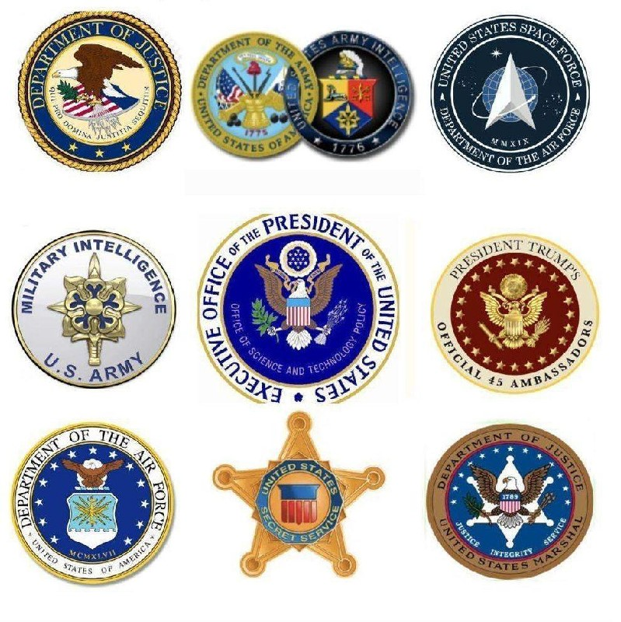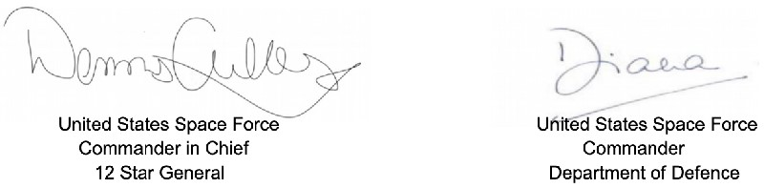

18