www.primarywaterinstitute.org www.primalwater.com.au

Primary Water Australian contact
The company in Australia is called Sustainable Water CQI linited.
The guys name is Robert Gourlay and he has developed a unique mapping program to search for primary water. He lives in Braidwood NSW

Any spring that arises on a mountain or hill could be primary water, especially if it is a permanent spring. Often found along fault lines. Otherwise you need to find it and then drill for it. This could require co-operation financially within a small group of people. These springs would not dry up even in a severe drought.
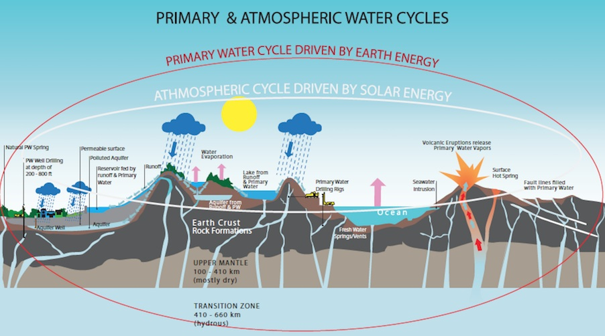
To read the small print go to the website.
Quotes - ancient proof for primary water
Genesis 7:11 King James
In the six hundredth year of Noah's life, in the second month, the seventeenth day of the month, in the same day were all the fountains of the great deep broken up, and the windows of heaven were opened. [Two separate events]

12 And the rain was upon the earth forty days and forty nights.
13 In the selfsame day entered Noah, and Shem, and Ham, and Japheth, the sons of Noah, and Noah's wife, and the three wives of his sons with them, into the ark.

Book Of Enoch: Chapter 65: 1 – 2:
1 After this he showed me the angels of punishment, who were prepared to come, and to open all the mighty waters under the earth:

