**This Notice is to all involved within,**

**Belligerent Queensland Government Councils.**

**Chief Executive Officer’s**

**Counsellors**

**LAWFUL NOTICE OF**

**Stop and Desist all Purported Lawful Fraternity.**

Acts of Treason, Treachery, Sabotage on Queensland People.

**This is a lawful notice.** Please read it carefully. It informs you and all concerned recipients of this notice. **It means what it says.** There are no hidden meanings or interpretations beyond the simple English statements herein.

**SILENCE IS ACQUIESCENCE, AGREEMENT AND DISHONOR - THIS**

**IS A SELF-EXECUTING DOCUMENT**

**Within the Universal Maxims of Law, equality before the law is paramount and Notice to Principal is Notice to Agent /**

**Notice to Agent is Notice to Principal.**

All addressed parties jointly and severally and applicable to all Successors, Nominees and/or Assigns in your own individual and private capacity.

Attention To:

Photo of

Belligerent

member

If in doubt in respect to any of the within mentioned matters, it is wise to seek independent lawful advice as ignorance of the law is no excuse and no defence.

**YOU** **HAVE BEEN NOTICED AND WARNED: DO NO HARM or DO SO KNOWINGLY AND WILFULLY AT YOUR OWN RISK AND TO YOUR OWN DETRIMENT!**

We, and many others, look forward to receiving an appropriate and urgent response to this **open correspondence (not private/not confidential)**  written and sent without malice, vexation, frivolity, or ill-will, and with all natural, indefeasible, and unalienable ‘God Given’ rights, blessings, freedoms and liberties reserved - always and without recourse.

We reserve all our rights to pursue legal remedy against all parties in their private and public capacities for all harassment, harm and stress etc., past present and future in a Court of competent jurisdiction.

**The Peoples Queensland as an Original State as part of the Commonwealth at its establishment.**

**Separation of Powers**

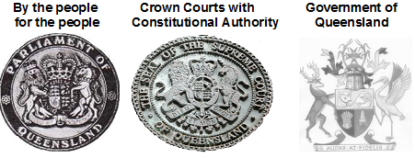

**Treason from within**

**Only Political Parties (Not the People) changed the definition of Queensland in 1985 and created**

**their Queensland to the status to their**

**sovereign, independent and federal nation.**

**No Crown and Constitutional Authority**

**Writing on paper, we are fighting the PEN.**

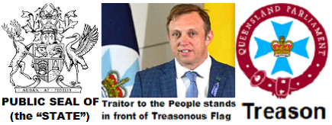

**Political Parties Queensland to the status of a**

**sovereign, independent and federal nation.**

**They had to remove the Letters Patent 29th October 1900,**

**Crown and Constitutional Authority**

**from the State Governor to give Royal assent.**

**This was and still is**

**High Treason**

**Political Parties Queensland Acts tell us**

**all Acts from the Australia Acts forward are only**

**purported Acts with purported enactments,**

**All Acts are created within their Political Party Private,**

**Queensland Parliament,**

**Private Acts** **not to affect rights of others,**

**None of these Acts have Crown and Constitutional Authority, therefore NO Royal assent.**

 **Treason Seal**

**Local Government Act 1993 No.70**

**PART 3—INTERPRETATION**

**˙Definitions**

**4.** In this Act—

**“local government” means a local government established under this Act;**

© The State of Queensland 1993

**Only Private Acts can be copyrighted** ©

**Treason Seal**

**Local Government Act 2009 Act No.17**

© State of Queensland 2009

**Only Private Acts can be copyrighted** ©

**All these Political Party Queensland Acts**

**are extortion rackets using Treason.**

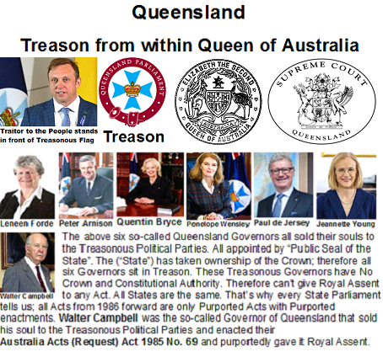

I _ _  _ _  _ _ _ _ _ _ _ _ _ _ _ _ _ _ _ _ _ _ _ _ _ _ _ _ _ _ _ _ _ _ _ _ _

**have transferred the guilt of knowledge of Treason to you**

_ _  _ _  _ _ _  _ _ _ _ _ _ _ _ _ _ _ _ _ _ _ _ _ _ _ _ _ _ _ _ _ _ _ _ _ _

**and to your heirs and successors.**

**In 1999 we voted all the Political Parties and their Republic Acts OUT and voted to stay as a Constitutional Monarchy**

**Queensland**

**CRIMINAL CODE ACT 1899 Punishment in special cases**

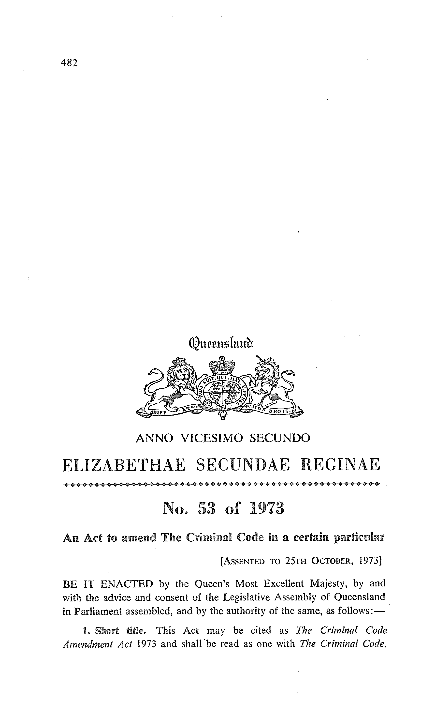



**CRIMINAL CODE ACT 1899**

**(63 Vic. No. 9)**

An Act to Establish a Code of Criminal Law

**(as amended)**

**Establishment of Code—Schedule 1**

**2.(1)** On and from 1 January 1901, the provisions contained in the Code

of Criminal Law set forth in Schedule 1 (**“the Code”**) shall be the law of

Queensland with respect to the several matters therein dealt with.

**BEFORE** being **CRIMINALLY AND FRAUDULENTLY SEALED** with the Corporate

Public Seal of (the **“State”**) **AND COPYRIGHTED** © State of Queensland,

the *Criminal Code Act 1899* [63 Vic. No. 9] as amended to 1934 [26 Geo.V. No.11],

included the following:-

**Punishment in special cases**

**˙Public seals etc.**

**1.** If the thing forged—

(a) purports to be, or is intended by the offender to be understood to

be or to be used as, the great seal of the United Kingdom or of

Queensland, or Her Majesty’s privy seal, or any privy signet of

Her Majesty, or Her Majesty’s royal sign manual, or the seal of

the Governor, or any public seal lawfully appointed to be used for

authenticating an act of state in any part of Her Majesty’s

dominions; or

(b) is a document having on it or affixed to it any such seal, signet, or

sign manual, or anything which purports to be, or is intended by

the offender to be understood to be, any such seal, signet, or sign

manual;

the offender is liable to imprisonment with hard labour for life.