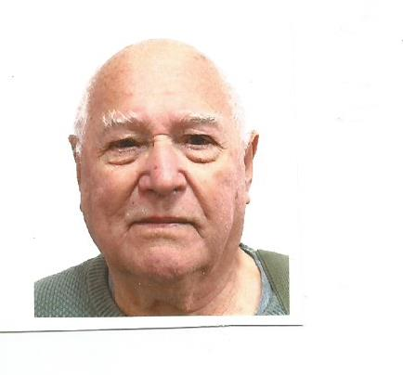

We, the undersigned, NOMINATE Leonce Kealy for Sheriff for Western Downs QLD

I am asking for your support to enable me to join the Common Law Council as a Sheriff so that I can at least do something within my area. This is a voluntary position and not a Government position. However, it is designed to bring about justice when no other avenue is available. Common Law Sheriffs have the power to convene citizen juries and Common Law courts, deputize anyone to perform arrests, and to form and train Citizen Militias, win over the police and other agents of the old regime to act according to common law, and reclaim the land, and the wealth, of the nation for all its people.

Other interested people can also become a Sheriff in their area by joining the clcaustralia.com and find out what needs to be done in order to achieve same. Anyone anywhere can nominate, you do not have to be in the area that the person is seeking nomination.

Your whole family can nominate me if they are of voting age by signing below and returning to me by email: eireuklk@gmail.com or post 121 Happiness Road, TARA QLD 4421 Australia

NAME:………………………………………ADDRESS:……………………………..

……………………………...

SIGNATURE:……………………………….

NAME:………………………………………ADDRESS:……………………………..

……………………………...

SIGNATURE:……………………………….

NAME:………………………………………ADDRESS:……………………………..

……………………………...

SIGNATURE:……………………………….

